Q1: 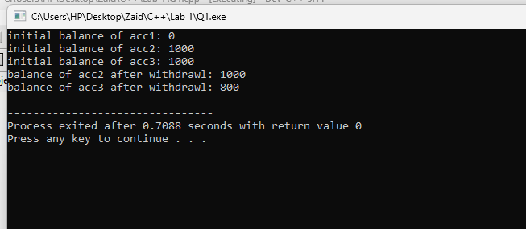

Q3: 